CAFOs Case Neg – FJ Lab DDI

AT: Advantage 1

1NC

Neolib is the best way to combat social and economic inequality
Luka Ladan 19, 6-14-2019, "Capitalism Remains the Best Way to Combat Extreme Poverty," Catalyst, https://catalyst.independent.org/2019/06/14/capitalism-remains-the-best-way-to-combat-extreme-poverty/ JM
But just how common is extreme poverty in America? Are extreme poverty rates high and rising, as many claim? Last year, the United Nations published a report suggesting there are more than 18 million Americans living in extreme poverty—roughly the equivalent of Chile’s entire population. As Philip G. Alston, the author of the report, put it: “[America’s] immense wealth and expertise stand in shocking contrast with the conditions in which vast numbers of its citizens live. About 40 million live in poverty, 18.5 million in extreme poverty, and 5.3 million live in Third World conditions of absolute poverty.” Say it ain’t so! Well, it ain’t really so. More recent research paints a much rosier picture. According to a May 2019 study co-authored by University of Chicago professors and Census Bureau researchers, the American experiment may not be perfect, but extreme poverty remains a statistical anomaly. Specifically analyzing $2-a-day poverty—that is, the number of Americans living on $2 or less per day—the study’s co-authors found that only 0.11 percent of Americans live in extreme poverty. That comes out to roughly 336,000 people—still too high, but nowhere near 18 million. Moreover, the study concludes that the extreme poverty rate for parents—whether single or married—is virtually zero. Again, America is not perfect. Poverty lingers, even here. But the status quo could be a whole lot worse: It may be difficult to become a member of the top “one percent,” but it is even harder to fall into extreme poverty. The good fortunes of most can be traced to the free exchange of goods and services for mutual gain. While an imperfect system, capitalism remains our most effective weapon in fighting extreme poverty. As we’ve seen across continents, the freer an economy becomes, the less likely its people are to become entrapped in extreme poverty. This can be corroborated by tracking the rise of “economic freedom,” which is related to the openness of a country’s markets and corresponding increases in living standards. Over the past 25 years, the global average economic freedom score—as calculated by the right-leaning Heritage Foundation—has increased by 3.2 percentage points, with many countries joining the ranks of at least the “moderately free.” Indeed, global economic freedom has experienced a nearly six percent increase since 1995—after the Soviet Union’s collapse. Capitalism is more commonplace now than ever before. And how have extreme poverty rates fared in that time? Trending down—way down. During the early 1980s, more than 42 percent of the world’s population lived in extreme poverty (earning less than $2 a day). In the Soviet Union, for example, 20 percent of the population—over 43 million people—lived on less than 75 rubles a month (roughly $120). Fast forward to the 21st century, and less than 10 percent of the world’s population is extremely poor—a 33 percent decrease. The left-leaning Brookings Institution estimates that someone escapes extreme poverty every 1.2 seconds. Consider it this way: Even though the world’s population has increased by more than two billion people since 1990, the net number of extremely poor people has been slashed by nearly 1.2 billion. In today’s era of globalization, about 130,000 people rise out of poverty every single day. That’s like the entire city of New Haven, Connecticut leaving extreme poverty in a day’s time. Or take China, which has opened many sectors of its economy in recent decades. Since 1995 alone, the Asian country’s economic freedom score increased from 52 to 58.4 points—outpacing the rest of the world. In roughly that same period of time, the Chinese economy lifted 800 million people out of extreme poverty. That’s right: 800 million Chinese people—nearly three times the U.S. population. While still far from a “free economy,” China’s newfound openness to free-market principles is correlated with the most substantial example of poverty reduction in the history of the world. Even if correlation does not always equal causation, that accomplishment is difficult to ignore. Granting people the freedom to voluntarily make mutually beneficial exchanges of goods and services has been the most effective anti-poverty solution to date. As more of the world allows the exercise of such freedom, expect poverty to decline even further.

The aff’s focus on technocratic solutions reinforces trust in the neoliberal state
Ben Wardle in 2017
Griffith Law School, Griffith University, Gold Coast, Australia; Legal facades; GRIFFITH LAW REVIEW, 2017 http://dx.doi.org/10.1080/10383441.2016.1273080
A key contribution to the examination of the relationships between material forms of ideology and ideological beliefs comes in Louis Althusser’s essay Ideology and Ideological State Apparatuses,12 and so our enquiry begins here. Althusser systemises the materiality of ideology in his assertion that dominant institutions and practices like education, law, prisons, literature and sport must be ‘steeped’ in ideology for the relations of domination inherent in capitalism to be maintained and reproduced.13 Althusser’s crucial development is that ‘ideology always exists in an apparatus and its practice, or practices. This existence is material’.14 Rituals and practices generated by ideological apparatuses permeate the values necessary for the reproduction of exploitative social relations.15 Althusser’s theory reverses the usual assumption that beliefs presuppose material practices. For Althusser, like theologian Blaise Pascal, it is the ritual that produces the belief: we are indebted to Pascal’s defensive ‘dialectic’ for the wonderful formula which will enable us to invert the order of the notional schema of ideology. Pascal says more or less: ‘Kneel down, move your lips in prayer, and you will believe.’ He thus scandalously inverts the order of things.16 By kneeling, praying or engaging in other Christian rituals a subject of Christianity is created prior to the conscious acceptance of Christian reasons for belief. As Žižek points out, the reasons for accepting a particular belief system like Christianity (getting into heaven, a connection with an all-powerful god, Jesus’s sacrifice, etc.) are only convincing to those who already believe.17 Instead of our acts reflecting our beliefs it is our beliefs that are born out of our acts.18 This means that the materialisation of ideology in social rituals or other material forms is a foundational source of the internalisation of the values necessary for the maintenance and reproduction of social stratification. If the basis of ideological beliefs is the materialisation of ideology in practices then beliefs are not exclusively internal but external. The most seemingly universal, heartfelt and innermost convictions can stem from material social practices. In Žižek’s words: This seems also to be a basic Lacanian proposition, contrary to the usual thesis that a belief is something interior and knowledge something exterior (in the sense that it can be verified through an external procedure). Rather, it is belief which is radically exterior, embodied in the practical, effective procedure of people. It is similar to Tibetan prayer wheels: you write a prayer on a paper, put the rolled paper into a wheel, and turn it automatically, without thinking…In this way, the wheel itself is praying for me, instead of me – or, more precisely, I myself am praying through the medium of the wheel. The beauty of it all is that in my psychological inferiority I can think about whatever I want, I can yield to the most dirty and obscene fantasies, and it does not matter because – to use a good old Stalinist expression – whatever I am thinking, objectively I am praying.19 Prior to the acceptance of a particular belief structure subjects are in a state of unconscious belief or what Žižek calls ‘belief before belief’.20 When encountering the materialisation of ideology, such as through repetitive social rituals, a subject believes in a system of ideas without knowing it. The final conversion to a belief system is ‘merely a formal act by means of which we recognize what we have already believed’.21 This means it is the ritual that first creates a subject of ideology – ‘the “external” ritual performatively generates its own ideological foundation’.22 The externality of beliefs means rituals or other concretisations of ideologies such as architecture can believe in the place of subjects. In other words, beliefs are created by and can be deferred to practices, rituals, institutions, symbols, buildings and so on. Žižek provides a number of examples of this process including hired funeral weepers and canned laughter on television sitcoms.23 In each case the belief of individuals is externalised – it is the hired weeper who mourns in the place of the family member and it is the laughter track that laughs for the television viewer. And, to return to Pascal’s example, it is the kneeling and praying that believes in the place of the Christian. Crucially, this means that individuals can believe without internal convictions and against evidence contradicting their beliefs as their beliefs can be manifested in material acts such as kneeling and praying. As the materialisation of ideology effectively believes for the individual there is a distance between the external belief and ‘inner’ convictions. Žižek’s exemplar here is physicist Niels Bohrs’ response to a surprised visitor’s questioning of the hanging of a horseshoe above his door for good luck: Bohr snapped back: ‘I don’t believe in it either; I have it there because I was told that it works even if one doesn’t believe in it!’ What this paradox makes clear is the way a belief is a reflexive attitude: it is never a case of simply believing – one has to believe in belief itself. That is why Kierkegaard was right to claim that we do not really believe (in Christ), we just believe to believe – and Bohr simply confronts us with the logical negative of this reflexivity (one can also not believe one’s beliefs…).24 This example shows that concretisations of ideologies in objects like horseshoes or buildings have the capacity to permeate the values necessary for the ideology’s reproduction even in the face of individual resistance and evidence refuting the belief system. Of course this does not mean that all materialisations of ideology are effective in the task of instilling belief or believing in the place of individuals. Even so, the materialisation of ideology is certainly central to the maintenance and reproduction of social stratification. The critique of legal ideology must consequently include an examination of how ideology is concretised in ways that permeate the values

The world is getting better because of capitalism
Tupy 18 (Marian, editor of HumanProgress.org and a senior policy analyst at the Center for Global Liberty and Prosperity, 4/8/18, “10 Years After the 2008 Financial Meltdown, How Has Capitalism Performed for Humanity?”, https://fee.org/articles/10-years-after-the-2008-financial-meltdown-how-has-capitalism-performed-for-humanity/, )
Things Are Still Getting Better, Especially for the Developing World It is hardly original to acknowledge that all human institutions, including liberal democracy and free enterprise, suffer from their share of imperfections. But, perfection is not for this world. As the German philosopher Immanuel Kant observed in 1784, “Out of the crooked timber of humanity no straight thing was ever made.” That said, it is very important to remind ourselves that, compared to the alternative political and economic arrangements (Russia and China spring to mind), open societies continue to do very well. In spite of all of their problems and shortcomings, open societies remain in the richest, safest, healthiest, and happiest places on Earth. And while we may spend inordinate time and effort navel-gazing, immigration patterns clearly show that millions of people from other parts of the world would be happy to make a new start in our neck of the woods. To be sure, critics and opponents of open societies have made some electoral gains in the West, including, most significantly, in the United States. But no Western nation embraced autarky or dictatorship, which suggests that the intellectual consensus surrounding the superiority of liberal democracy and free enterprise continues to hold. That is surely a marked improvement on the political and economic disasters that followed after the Great Depression broke out in 1929. Depending on the measure used, the global spread of economic and political freedoms has either plateaued or suffered a slight reversal. Still, instances of democratic retreat (Turkey) are often offset by instances of democratic awakening (Nigeria). Likewise, economic disasters (Venezuela) tend to be offset by economic success stories (Peru). In contrast to countries in the West, the developing world escaped from the Great Recession relatively unscathed, and progress on most measures of human well-being continued unabated. These improvements are too numerous to mention, but suffice it to say that the United Nations’ Millennium Development Goals, which aimed at poverty reduction, better education, greater gender equality, reduced child mortality, improved maternal health, combatting disease, and higher environmental quality, have met with considerable success. Good News Getting Good Press Crucially, the concept of human progress is finally getting the press it deserves. When the University of Maryland economist Julian Simon performed the role of global Mr. Optimist in the 1980s and 1990s, his was a lonely and thankless task. That is no longer the case.

No solvency-Neoliberalism good
Leob’17 (Marc David Leob, “Neoliberalism has done the most good for the most people of any economic system in human history”, 4 June 2017, Medium.com, retrieved from: https://medium.com/@marcdloeb/neoliberalism-has-done-the-most-good-for-the-most-people-of-any-economic-system-in-human-history-9a9bd91eda4c //jh)

Neoliberalism is a term you’ve likley heard, but probably don’t know the meaning of. I don’t blame you. The opponents of neoliberalism can’t seem to agree what it is either, besides something bad. Socialists use it to plaster “new democrats” like Sen. Hillary Clinton. Alt-Righters use it to attack reaganite conservatives like Gov. John Kasich. Libertarians use it to slap moderates like Gov. William Weld.
Despite the confusion, neoliberalism is a defined term, with a long history. It is, in short, the combination of free markets and free trade with sensible regulations and a reasonable safety net.
Noble Prize winning economist Milton Friedman was one of the early adopters and definers of the term. In a 1951 essay, he laid out the basics of neoliberalism, as an alternative to both 19th century laissez-faire economics and 20th century collectivism, combining elements of both: “Neo-liberalism would accept the nineteenth century liberal emphasis on the fundamental importance of the individual, but it would substitute for the nineteenth century goal of laissez-faire as a means to this end, the goal of the competitive order. It would seek to use competition among producers to protect consumers from exploitation, competition among employers to protect workers and owners of property, and competition among consumers to protect the enterprises themselves. The state would police the system, establish conditions favorable to competition and prevent monopoly, provide a stable monetary framework, and relieve acute misery and distress. The citizens would be protected against the state by the existence of a free private market; and against one another by the preservation of competition.”
From it’s founding in the early post war years neoliberalism slowly matured as a political and economic ideology. Neoliberalism erupted onto the forefront of policy and politics during the 1980s as a response to the collapse of the post war economic consensus. The high inflation and economic turmoil of the 1970s were replaced by two and a half decades of consistent growth. Despite the dominance of the ideology, few major politicians identified with the term. Reagan and Bush Sr. called themselves conservatives, Bill Clinton called himself a “new democrat.” This allowed neoliberalism to be defined by its opponents, rather than supporters (much like the big bang theory and capitalism), creating the above mentioned confusion.
The 2008 crisis shook confidence in the neoliberal order. In response to the slow recovery, many began to turn to more hetrodox schools of thought, socialism, the Alt-right, libertarianism and so forth. Political parties and candidates have increasingly stepped out of the mainstream, challenging core tenets of neoliberalism: free enterprise, free trade, immigration, tolerance, international cooperation, sensible regulation and so forth.
So what good has neoliberalism done for us? There must be something wrong with it if so many ideologies and political groups assault it daily? In fact the opposite is true. Simply put, we are living in the freest, richest, most equal and safest time in human history, largely due to neoliberal capitalism.
Wealth of Nations
International cooperation and economic relations, cores tenants of neoliberalism, are some of the keys to world peace. Trade between nations reduces the incentives to fight. There has never been a war between two capitalist democracies. International institutions such as the United Nations, World Bank and World Trade Organization provide a medium for disputes to be settled with words, not arms. There are fewer deaths from conflict today then there has been in any other point in human history.

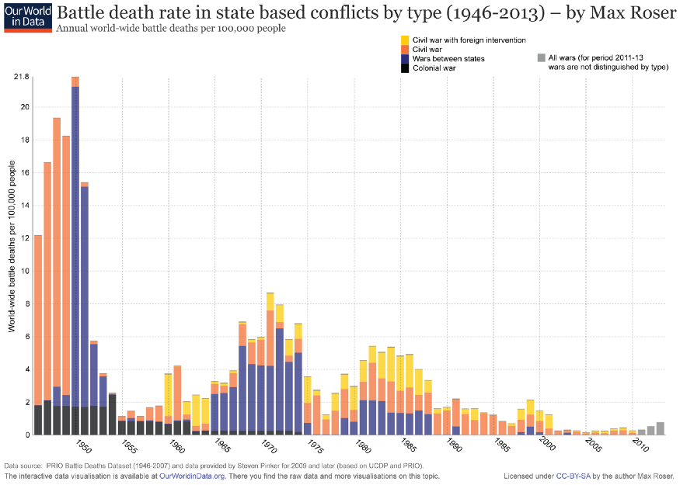
https://ourworldindata.org/wp-content/uploads/2013/06/ourworldindata_wars-after-1946-state-based-battle-death-rate-by-type.png
Free trade has one of the most assaulted neoliberal principles in recent years. Bernie Sanders asserts that trade allows American corporations to exploit poor foreigners. Donald Trump declares that it costs Americans their jobs. In fact, free trade enriches both the American poor and the global poor. A factory job in China pays 5–10 times higher wages than subsistence farming. When factories are forced to close due to new trade barriers, foreign workers end up in worse jobs “or on the streets — and…a significant number [are] forced into prostitution.” “Because the countries are poor, even what look to us like bad jobs at bad wages are almost always much better than the alternatives.” Free trade has smashed global poverty, which is at it’s lowest level in human history.

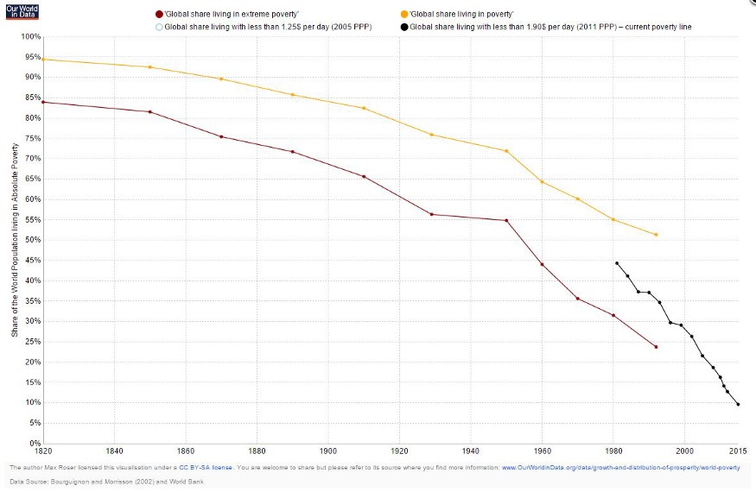
http://www.cookandbynum.com/wp-content/uploads/2015/10/Chart-21.jpg
Poor people in the United States benefit from trade and globalization too. Lower income people spend more of their income meeting the basic needs of life. A drop in food prices means little to rich people but a significant improvement in livelihood for poor people. Ending free trade would disproportionately hurt poorer Americans, and “would cause the poorest 10% of consumers across 40 countries to lose 63% of their purchasing power.” The average American household is effectively 18,000 dollars richer than it would be without trade.
Nations with freer economies and more open trade are wealthier than their closed counterparts. This is evident in broad statistical examinations of the world economy. There is a strong correlation between a nation’s combined index of economic freedom (including trade, regulatory and labor freedom) and overall prosperity.

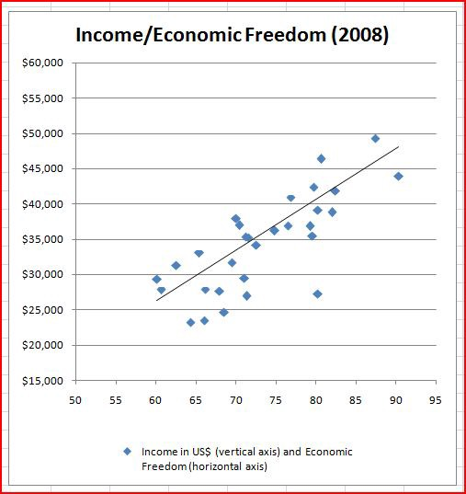
http://www.econlib.org/library/Columns/y2010/Sumnerneoliberalism.html
Economic liberalism can mean a lot on the smaller scale too. Take housing for example. Cities such as Dallas and Atlanta, with freer housing markets, are far more affordable than restricted markets like New York and San Francisco. Despite spending billions on “affordable housing” only 1 in 4 housing units are affordable to the middle class in NYC. The City Government of Dallas spends almost nothing on affordable housing yet 4/5 homes in Dallas are affordable (despite the fact that Dallas is growing far faster than New York is). No expensive US housing market allows their supply to grow at a rate in concert with demand. No expensive city builds enough housing. Policies such as rent control, height restrictions, land use control and mandatory inclusionary housing are intended to help people (and do aid a few), but end up hurting far more, poor people in particular, by reducing housing supply and pushing up prices.
Finally, in unconstrained housing markets poor people are unlikely to be displaced because of gentrification.
The Equalizer
Contrary to claims by populist political candidates, economic liberalism has the potential to reduce inequality too. On the subject of housing, most of the growth of wealth inequality in the United States over the past few decades has been driven by higher housing costs. Land and property owners in New York and San Francisco have become hugely wealthy because prices have risen so rapidly.

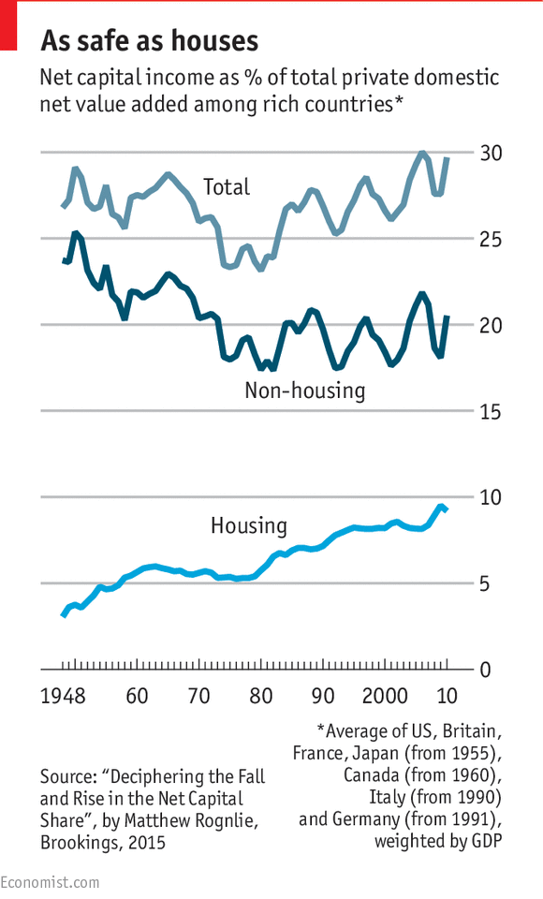
Additionally high housing costs amount to “opportunity hoarding” by the upper middle and upper class. Working class people, instead of moving to highly productive and rich cities like New York instead move to poorer and less productive cities with worse jobs, education and infrastructure, trapping them at lower income and productivity levels.
Liberalizing the housing market, thereby lowering housing costs, would reduce inequality and boost growth. “Enrico Moretti and Chang-Tai Hsieh estimate that the U.S. economy would be 10 percent bigger if three cities (San Francisco, San Jose, and New York) had the zoning regulations of the median American city.” By using “data from 220 metropolitan areas [they found] that these constraints lowered aggregate US growth by more than 50% from 1964 to 2009.”
Globally inequality is down due to neoliberalism as well. Free trade and comparative advantage have massively enriched the once impoverished nations of the world. The gap between poor and rich countries (exasperated by communism and colonialism) has closed in the past few decades.

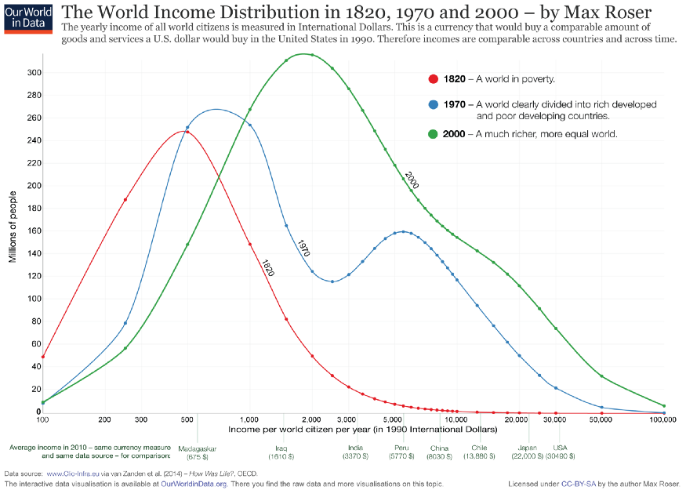
https://ourworldindata.org/wp-content/uploads/2013/11/ourworldindata_worldincomedistribution1820to2000.png
Other neoliberal policies have the potential to lower inequality. The American federal tax code is over 11,000 pages long (and jumps to 70,000 if you include supplementary material). Our regulatory code is orders of magnitude larger. The complexity of these systems inherently benefit the wealthy. Large corporations and rich people can afford expensive lawyers to find every exemption and tax break. This gives large incumbent companies and advantage over their smaller rivals, decreasing economic dynamism, pushing up prices and down wages. Another tax neoliberals wish to get rid of, corporate income taxation, is primarily a tax on the wages of workers and the pockets of consumers, not the wallets of the CEO or shareholders.
By radically simplifying our tax and regulatory system we can re-level the playing field.
The Safety Net
However capitalism is not a perfect system. What separates neoliberals from libertarians is that neoliberals recognize that markets sometimes fail when left completely unsupervised. Anti-trust regulations are needed to maintain competition and protect consumers. Externalities such as pollution and CO2 should be taxed, to return their costs to the people who created them.
A good education system is essential to promoting opportunity and growth. Government intervention in the market is also needed when there is limited or no consumer choice (such as infrastructure and emergency care [people usually don’t take the time to shop hospitals if they are having a heart attack]). The rights of minorities (sexual, religious, racial, ethnic) also need to be protected.
Capitalism creates unparalleled prosperity, but sometimes doesn’t distribute income and opportunity fairly (though I maintain that it provides the most fair baseline). Neoliberals support progressive taxation (preferably progressive consumption taxation), land value and inheritance taxes to improve equality. Neoliberalism also supports the idea that a minimum standard of living should be provided, preferably through cash grants to the poor (slowly trailing off as income rises), instead of our current tangled web of 126 welfare programs, which don’t cooperate, allow people to fall through the cracks and disincentivize increasing one’s own income.

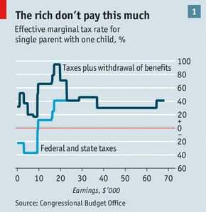
Unlike what some people (on both the left and the right) attest lower income folks are not the victims of some mental impairment and are perfectly capable of spending money wisely. Cash is the superior form of welfare because people known their own circumstances better than a central government.
The Neoliberal Manifesto
In short neoliberalism wants to harness the power of the free market to create wealth, prosperity and peace. At the same time neoliberalism recognizes when it fails and when government should step in and make a correction. Though neoliberals would prefer those corrections take some market based form (Negative Income Tax, Carbon Taxes, School Vouchers etc.).
Despite all the good it’s done there is an increasing hostility to the ideas of neoliberalism. The Alt-Right hates free people. The Populist Left hates free markets. Libertarians reject the idea that government intervention is sometimes required. It’s time for neoliberals to push back, to remind America and the World how much it has improved the lives and livelihood of everyone around the globe and what yet there is to be done.

Cap Case Turn

Their attempt to reform capitalism with the administrative state and governmental regulations to solve for social inequality maintains capitalism as an economic system and forecloses the revolution we need against capitalism.
John Peterson 18, "You Can’t Reform Capitalism—It Must Be Overthrown," In Defence of Marxism, https://www.marxist.com/you-can-t-reform-capitalism-it-must-be-overthrown.htm
As Marxists, we support any and all reforms that improve the lives of the workers and poor, even within the limits of capitalism. But there is a difference between fighting for concrete reforms that raise class consciousness, confidence, and unity, and believing that capitalism can be “reformed” out of existence. We do not content ourselves with a “kinder, gentler” form of wage slavery. A system that cannot productively make use of the diverse talents of every individual for the greater good, and which condemns millions to “enforced idleness” has no right to rule over the majority. We should also understand that those social welfare programs that do exist are by-products of revolutionary struggle and are maintained solely to prevent the threat of revolution. Our historic aim is not to win a few more crumbs for the destitute, but to ensure that everyone on the planet has food, clothing, shelter, education, and long, productive, healthy lives. To be sure, reformism is a natural first stage of political awakening. The idea that we should try to tone down this or that “excess” of capitalism seems the only “pragmatic” thing to do. But there is a difference between the reformism of the average person, who can’t yet conceive of any system that goes beyond what they have experienced so far in their lives, and that of committed reformists who consciously reject the need for revolution, or at best, postpone it to the indefinite future. Having no confidence in themselves or the working class, they eviscerate Lenin of his revolutionary essence and embrace the ideas of the German Social-Democrat Karl Kautsky. Ultimately, as with all utopian socialists and reformists, their aim is to “pressure” the capitalists and their politicians to “do the right thing.” However, history provides ample evidence that this is a dead end. As Leon Trotsky succinctly put it, “No amount of ‘pressure’ can make the bourgeoisie stop being the bourgeoisie: it must be overthrown.” Nevermind that in the midst of an organic crisis of capitalism, there is no material basis for reforms, only counterreforms. Some on the left believe they have stumbled upon a “third way” between reformism and revolution. They propose that the way forward lies in reviving the ideas of the “New Left,” specifically, those of André Gorz and his conception of “non-reformist reforms.” Now, if what they mean by this is a reform that doesn’t limit itself to capitalism, cannot be fully realized within this system, and therefore helps people draw the conclusion that a socialist revolution is necessary, then this would effectively be a classical Marxist “transitional demand” by another name. But that’s not what they mean. They envision reforms that can somehow “decommodify” this or that strategic sector of the capitalist economy, thus “undermining its hegemony,” in a “war of position” waged from within the limits of the system. Take, as an example, the much-needed struggle for universal socialized healthcare. Those activists who fight for “Medicare for All” in the abstract—in isolation from the broader fight for a mass socialist party and class struggle trade unionism—end up merely trying to exert “pressure” on capitalist politicians. Canvassing is an important way to meet and engage workers and to explain the ideas of socialism. But if the concrete result is simply to get signatures for a petition “urging” the Democrats to “do the right thing,” then not a single step towards universal healthcare is taken, never mind socialism. The Democrats are a party of big business. They are not about to “decommodify” the health insurance and provision industries, which are among the most profitable sectors of the capitalist economy. To sow any illusions whatsoever in the Democratic Party is to sow confusion and disappointment. Those who argue for “non-reformist reforms” also have a formalistic understanding of what a revolution is and is not. As a result, they focus on the so-called “war of position” instead of prioritizing the building of a class-independent mass revolutionary party in advance of the revolution. They have no perspective of future mass movements of the workers, of a revival of the class struggle in the unions and in politics. While critical of capitalism, they don’t fully explain the system or how it can be changed through working-class organization, mobilization, and revolution. They do not deny that the system is exhausted and reactionary, but they grudgingly accept it nonetheless. This is a perspective of cynical pessimism and surrender, veiled in the language of academic sagacity. The idea that the workers are “not ready” for socialism is a cop-out. Millions came out in support of Bernie Sanders’s call for “revolution against the billionaire class.” It was his capitulation to the Democratic Party that led to mass abstention, protest votes and the eventual victory of Donald Trump, not a lack of enthusiasm for socialism and revolution. Fortunately for humanity, working-class consciousness can, does, and will catch up with a bang, and this will completely transform the situation. When precisely this will happen is impossible to say. But in society, as in nature, similar conditions lead to similar results. The task of socialists is to painstakingly prepare for such dramatic changes in consciousness. Our role is not to artificially try to “build working class power” or “spark” the movement, but to prepare ourselves to help channel the pent-up energy of the working class into useful revolutionary change once it inevitably moves into action to change society. We must also not forget that betrayal is inherent in reformism. In one European country after another in the recent period, the reformists have played the role of derailing revolutionary energy into channels that are safe for capitalism, even before they get anywhere near power. In an epoch of crisis and counterreforms, “non-reformist reforms” will end up as run-of-the-mill reformism without reforms. As Marxists, we must enter a friendly and patient dialogue with those who have honest reformist illusions but aren’t committed reformists. Most Americans, even on the left, have never been presented with a revolutionary socialist program. But illusions in reformism cannot last forever. American workers are pragmatic by nature and will judge parties and politicians on the basis of their experience. At a certain stage, if revolutionary socialists are present in sufficient numbers to reach the broader working class with our ideas, millions will enthusiastically embrace the need for socialist revolution. The task of Marxists is to help shorten the time needed to draw these conclusions—but we do not have all the time in the world to do so. That capitalism passes through different phases of development is absolutely true. But to propose, as some on the left do, that it is only a “neoliberal” version of capitalism that has failed is patently wrong. Capitalism remains capitalism from its dynamic infancy to its senile decay. It is predicated on the merciless exploitation of wage labor and is more than happy to make use of even crueler modes of exploitation in its relentless quest to accumulate, concentrate, and expand capital. To argue for the continuation of any form of this system is to settle for a status quo of poverty, ignorance, exploitation, and oppression. This at a time when the objective potential for an entirely different way of organizing society is abundantly evident. In essence, this is what is meant by the concept of “late capitalism,” which reflects the instinctive understanding among the youth the “old society is pregnant with the new.” In an article titled, “How to Be an Anticapitalist Today,” published in Jacobin, the author concludes: “Give up the fantasy of smashing capitalism. Capitalism is not smashable, at least if you really want to construct an emancipatory future.” The American workers and youth can do without this kind of learned defeatism. A better future may seem out of reach as the economic, political, and social crisis grinds on, with even worse to come. But as the immortal revolutionary John Brown expressed it, “I cannot remember a night so dark as to have hindered the coming day, nor a storm so furious or dreadful as to prevent the return of warm sunshine and a cloudless sky.” That is the sort of revolutionary optimism we must be filled with. As Leon Trotsky explained, the crisis of humanity is the crisis of working-class leadership. A bold leadership with a confident vision of the socialist future is what we must build. History and the youth are on our side. The sooner we get this over with, the sooner future generations will get to live in a world of superabundance without the state, money, or compulsion of any kind. Join the International Marxist Tendency and help us fight for these ideas in the socialist movement.

Capitalism ensures resource conflicts, recreates the social and economic distress they talk about in their 1ac
Bhagwat, 11 (Vishnu, former Chief of the Naval Staff of India, Thee Weaponization of Space: Corporate Driven Military Unleashes Pre-emptive Wars, July 13, 2011, http://www.globalresearch.ca/index.php?context=va&aid=21432)
We must understand the reality of our present lawless world, where corporate driven military might unleashes pre-emptive wars, invasions and occupations and the UN system stands paralyzed , its Charter disregarded , the Treaties and conventions signed and ratified , flouted at every step . It is necessary for us to focus on the stark truth that those treaties and conventions do not protect humanity from the forces that want to dominate and exploit the resources of the world using every weapon system and all mediums --be they land , sea , the seabed or space and if the world system does not create a balance very soon than even from military bases that may be established on the earth’s planetary system. Vladimir Putin, then President and now the Prime Minister of Russia, speaking at the European Security Conference in Munich on 10th February 2007, said: “The unipolar world refers to a world in which there is one master, one center of authority, one center of force, one centre of decision making. At the end of the day this is pernicious not only for those within the system , but also for the Sovereign himself from within ; what is more important is that the model itself is flawed because as its basis there is and can be no moral foundation for modern civilization ( and even less for democracy ). We are seeing a greater and greater disdain for the basic principles of international law. We are witnessing an almost uncontained hyper use of force in international relations , force that is plunging the world into an abyss of permament conflicts . I am convinced that we have reached that decisive moment when we must seriously think about the architecture of global security.” We have to move heaven and earth , the might of humanity to dismantle that decision making ruling elite in the ‘joint corporate –military board rooms ,’ be they located underground in the Strategic Command in Nebraska or at multi-locations in Wall Street , the City ( London ) or Tel a Viv . The unlimited quest for establishing monopoly over the planet earth’s resources and markets , has led the world to witness unending wars , sometimes referred to as ‘long wars’ , if that phrase makes it seem less destructive , and the unending pursuit of weapon platforms , for attaining ‘full spectrum dominance’ and the ‘Strategic Defense Initiative’ (SDI ) or the Star Wars initiated by the ‘free market’ of the Reagan administration and Thatcherism , accelerating the death and destruction that we have witnessed , all across the globe be it in Angola , Congo, Somalia, Afghanistan , Iraq , Palestine , Central and Latin America , Yugoslavia , Lebanon , Gaza and earlier in Korea, Vietnam and Cambodia among other countries with the UN Security Council in some cases acquiescing and even assisting .

AT: Adv 2

1NC

No solvency-Increasing government regulations doesn’t affect corporations as much as consumer-lead regulations.
Davies and Harrigan’18 (Antony Davies and James R. Harrigan|Antony Davies is associate professor of economics at Duquesne University in Pittsburgh. He hosts the weekly podcast, "Words & Numbers" with James R. Harrigan. James R. Harrigan is CEO of FreedomTrust. He hosts the weekly podcast, "Words & Numbers" with Antony Davies., “A Better Kind of Regulation”, 3 Jan 2018, US News, retrieved from: https://www.usnews.com/opinion/economic-intelligence/articles/2018-01-03/true-regulatory-power-resides-with-consumers-not-the-government //JH)
As President Trump talks about rolling back the regulatory state, it's worth pointing out something that politicians would rather us not know: There is no such thing as an unregulated industry. When it comes to doling out special favors to special interests, perhaps the only thing that benefits politicians more than a complex tax code is a complex regulatory code. People love to be "protected" from self-interested businesses and don't pay much mind to ever-increasing government regulation. But the opposite of a government-regulated industry is not an unregulated industry. The opposite is a consumer-regulated industry. And when it comes to regulations, businesses fear regulation by consumer far more than they fear regulation by government, and with good reason.
People who wring their hands over the evils of profit-seeking businesses forget that profit is only one side of the coin. The other side is loss. The more driven a business is to pursue profit, the more driven it will be to avoid losses. And when it comes to awarding profit and inflicting losses, consumers hold almost all the cards.
Last April, United Airlines violently expelled a paid passenger, Dr. David Dao, from his seat because United had overbooked the flight. Other passengers made video recordings of the altercation and posted them to social media. Within 24 hours, United's stock had plummeted by a quarter of a billion dollars as investors dumped the stock in anticipation of consumers boycotting United. Within days, other airlines announced that they would end their practice of overbooking flights. Why? Not only did they seek to avoid a similar debacle and possible consumer boycott, they hoped to pick up former United customers. Within days, major industry players were cowed by the consumers' might. This is regulation by consumer. Meanwhile, back in Washington, it took Congress a month to schedule hearings for the purpose of looking into the problem. By the time government got around to thinking about possibly regulating the industry, consumers had already meted out punishment and doled out rewards.

In 2012, Rush Limbaugh called Sandra Fluke a "slut" on his radio program. Within a matter of days, advertisers had pulled their financial support for Limbaugh's program. Why? In their pursuit of profit, advertisers feared that consumers would associate their products with Limbaugh and punish the advertisers by boycotting their products. Businesses were so afraid of consumers that they pulled their advertising. They did this not because consumers were withholding their money, not even because consumers had threatened to withhold their money, but because businesses feared that consumers might withhold their money. This is regulation by consumer.
In 1982, prior to tamper-proof seals, someone poisoned Tylenol on store shelves in Chicago. The Tylenol company immediately recalled all Tylenol everywhere, destroyed the product and re-issued new product. The cost of the recall was (in today's dollars) over one-quarter of a billion dollars. Tylenol didn't do this because of liability – Tylenol had violated no laws. Tylenol didn't do this because it feared the government. Tylenol did it because it feared consumers. Within a couple of months, Tylenol re-introduced its product with special tamper-evident seals. Although the FDA consulted with Tylenol in creating rules for tamper-evident packaging for drugs, it took Congress an additional seven years to pass legislation requiring tamper-evident seals.
Time and again, regulation by consumer has moved faster and been far more devastating than regulation by government. Yet politicians keep pushing for more regulation by government. For evidence, look at the amount of government regulation the average American faces on a daily basis. Government regulation has become so commonplace that almost nothing we do remains untouched. We wake up in our government-regulated beds, shower in our government-regulated bathrooms, eat government-regulated food in our government-regulated kitchens, drive to work in our government-regulated cars to government-regulated workplaces. Government regulates the air we breathe, the water we drink and the food we eat. And every level of government gets in on the act, from Washington all the way down to local zoning boards and animal control.
One need look no further than the Code of Federal Regulations for evidence of how pervasive regulation has become. The CFR contains all of the final regulations specified by the federal government. The first compilation of federal regulations, published in 1936, contained about 2,600 pages. By 2014, the CFR had grown to over 175,000 pages, covering everything from space exploration to how people must control their pets in San Francisco's public parks.

Many voters prefer government regulation because they simply do not appreciate the power they hold in the market. And in underestimating the power they wield as consumers, people ascribe near magical powers to legislative fiat. While regulation by consumer always works in favor of consumers, regulation by government often, perversely, works in favor of entrenched businesses. This is a result of a phenomenon known as "regulatory capture." In Pennsylvania, for example, people who want to braid hair for money must take a 300-hour course and pass a series of tests. This is required despite the fact that hair-braiders don't cut hair, don't work with chemicals and literally can't cause any real harm to customers that can't be fixed by combing out the hair and starting over. So who benefits from this government regulation? Established hair salons. The more hoops individual stylists must jump through to remain in business, the less competition established hair salons will have to endure. Chicago regulations make it very difficult for food trucks to co-exist alongside brick-and-mortar restaurants. This is to the benefit of brick-and-mortar restaurants, which would otherwise have to compete with businesses with lower overhead.
This is not to say that there is no place for government regulation. Regulation by consumer works well when property rights are clear and when harm can be remedied through civil action. Where property rights are unclear - for example, in the case of air and water rights - government regulation can help to ensure that resources aren't overused. And where damage to a consumer cannot be remedied – for example, in the case of drunk drivers killing people – government regulation can alter people's and business' behaviors before any harm occurs.
Our collective reaction to any problem is to look first to government regulation. That is the less powerful form of regulation. We should look first to consumers to regulate, and only rely on government regulation in those far fewer cases wherein consumer regulation isn't possible.
As for President Trump's apparent push to roll back the regulatory state, bring it on. Less regulation by government doesn't mean less regulation. It means more regulation by consumer.

Status quo solves – modern farming has enviro benefits
Robert Paarlberg 12, 6-12-2012, "The Environmental Upside of Modern Farming," WSJ, https://www.wsj.com/articles/the-environmental-upside-of-modern-farming-11612534962 //JM
Modern farming is better because it uses low-impact, “precision” techniques that require less land, less energy and fewer chemicals for every bushel produced. The secret has been to incorporate tools that use sensors, information and communications technology, big data, and even machine learning to reduce farming’s dependence on material resources. Traditional farming had already failed as a protector of the environment nearly a century ago—and scientific advances have long offered new ways to help the planet. In the 1930s, after low-yield cropping was extended onto the drought-prone Southern Plains, the soil blew away, creating the disastrous Dust Bowl. Cropland expansion could finally be halted in the 1950s, once scientists had developed higher-yielding hybrid seeds. In the 1970s, engineering advances allowed farmers to plant seeds in unplowed fields, which reduced erosion, conserved soil moisture, sequestered carbon and saved on diesel fuel. New irrigation systems then began to replace wasteful flooding, while lasers leveled the fields to eliminate surface runoff. In the 1990s, farm tractors acquired GPS auto-steering, which ended wasteful gaps and overlaps in the field. This was followed by digital soil mapping, which could tell “smart” farm equipment to apply chemicals at variable rates tailored to each location’s differing soil characteristics. The spacing of seeds can also be varied with astonishing, sub-inch precision thanks to modern GPS equipment. And genetically engineered seeds now allow farmers to protect against weeds and insects with fewer chemical sprays.

Transition not so good
Liz Carlisle 19, 19, 11-1-2019, "Transitioning to Sustainable Agriculture Requires Growing and Sustaining an Ecologically Skilled Workforce," Frontiers, https://www.frontiersin.org/articles/10.3389/fsufs.2019.00096/full
The first step toward growing an agroecologically-skilled workforce involves reducing the initial barriers to entry into farming, which may be even more challenging for farmers hoping to embrace such practices. One of the biggest barriers faced by would-be farmers is acquiring or gaining access to land, particularly land with adequate access to water. As development pressures and policies favor “productive” purposes like housing and infrastructure, national farmland acreage nationwide has decreased, often irreversibly. A recent report on farmland loss estimates a reduction of 31 million acres between 1992 and 2012 (American Farmland Trust, 2018), with African American and Native American farmers disproportionately affected by land loss (Dunbar-Ortiz, 2014; Newkirk, 2019). In California alone, 1.4 million acres of farm and grazing land were lost between 1984 and 2014, a decrease of about 50,000 acres per year (California Department of Conservation, 2019). That trend appears to be accelerating still further: according to the new USDA Agricultural Census, between 2012 and 2017, California land in farms declined by an average of 209,240 acres per year. In parallel—and perhaps as a result—remaining US farmland has steadily increased in value, with croplands doubling in appreciation in the 2004–2014 period (USDA NASS, 2017). The aging farm population would appear to present an opportunity for new farmers (including farm workers) to buy out retirees, but without robust land use policies, much of this farmland is instead being transferred to institutional investors, which means new farmers are more likely to be tenants than farmland owners (Calo and De Master, 2016). As tenants, farmers have less autonomy to make long-term management decisions—decisions which may pose a relatively greater challenge for farmers interested in pursuing agroecology. For example, tenant farmers may not be in a position to invest in perennial crops, conservation infrastructure, or soil health (Calo and De Master, 2016). Land is not the only major asset for which new farmers require staggering amounts of up-front capital: equipment, operating costs, and proper storage and post-handling facilities can require millions of dollars before farmers harvest their first crop (Schiller, 2017). These costs may be even higher for biologically diversified farms, as they tend to require more diverse and appropriately scaled equipment that may be used only at certain times of the year or only for specific crops. These farms also need to make upfront investments in soil health and ecosystem function, such as soil-building cover crops, compost applications, and hedgerows. Over time, these investments can reduce input costs and production risk, while boosting fertility, carbon sequestration potential, and drought resilience. But their economic benefits may not be realized for years, while farmers can face initial production risks from switching to new practices. Moreover, new farmers have few options for financing such investments without incurring significant debt, and new farmers using ecologically-informed management are particularly poorly served by federal crop insurance subsidies, half of which go to farms in the top 10% of crop sales (Belasco, 2017) and many of which undervalue or even deter sustainable farming practices (Woodard and Verteramo-Chiu, 2017).

Modern ag has benefits
Continuous Improvement, no date, "Modern Agriculture," Minnesota Soybean, https://mnsoybean.org/msrpc/modern-ag/
Reduced tillage Reduced tillage provides important benefits to the soil including reduced soil erosion, improved water infiltration, increased organic matter and improved overall soil health. In the U.S., 70 percent of soybean acres use reduced tillage, including no-till. Tile drainage Many Minnesota soybean farmers use tile drainage to help improve water quality and reduce soil erosion. Other advantages include more consistent yield, less plant stress, fewer plant diseases and less soil compaction. Another large benefit is the decrease of total surface runoff, protecting water quality. Crop rotation Eighty percent of soybean acres are used in crop rotation, improving soil health and reducing pest and weed issues. Many Minnesota farmers use a corn-soybean crop rotation. Cover crops A cover crop is a crop grown for the protection and enrichment of the soil. Today’s soybean farmers may use cover crops to reduce nutrient loss by taking up nutrients left over from the previous crop. The benefits are endless – including increased soil organic matter, reduced soil erosion and compaction, improved soil health and increased biological activity.

2NC – Squo Solves

XT - Squo Solves
Natasha Gilbert 19, 5-10-2019, "A middle path to sustainable farming," Knowable Magazine | Annual Reviews, https://knowablemagazine.org/article/sustainability/2019/middle-path-sustainable-farming
Alfalfa, oats and red clover are soaking up the sunlight in long narrow plots, breaking up the sea of maize and soybeans that dominates this landscape in the heart of the US farm belt. The 18-by-85-meter sections are part of an experimental farm in Boone County, Iowa, where agronomists are testing an alternative approach to agriculture that just may be part of a greener, more bountiful farming revolution. Organic agriculture is often thought of as green and good for nature. Conventional agriculture, in contrast, is cast as big and bad. And, yes, conventional agriculture may appear more environmentally harmful at first glance, with its appetite for synthetic pesticides and fertilizers, its systems devoted to one or two massive crops and not a tree or hedge in sight to nurture wildlife. As typically defined, organic agriculture is free of synthetic inputs, using only organic material such as manure to feed the soil. The organic creed calls for caring for that soil and protecting the organisms within it through methods like planting cover crops such as red clover that add nitrogen and fight erosion. But scientists bent on finding ways to produce more food globally with as little environmental impact as possible are finding that organic farming is not as green as it seems. In a simple contest of local environmental benefits, organic wins hands down. That doesn’t hold true on a global scale, though, because organic farming can’t match the high-yield muscle of big agriculture. A widespread shift to organic would leave billions hungry, researchers predict, unless farmers put more land to work by turning now-unfarmed habitats into food-producing fields — doing more harm than good to natural ecosystems. “Organic farming is often seen as synonymous with sustainable farming, but it is not the Holy Grail of sustainable agriculture,” says Verena Seufert, an environmental geographer at VU Amsterdam who studies sustainable food systems. But the strategies being tested in those fields in Iowa, and similar methods finding their way onto hundreds of millions of acres of farmland globally, might just be. In experiments in Europe and across North America, agronomists are testing hybrid approaches that weave together the green touch of organic farming with a dash of chemical fertilizer and pesticide applied only when needed — an approach known as low-input agriculture. They hope that this cocktail of farming techniques will steer future farming to a truly sustainable footing.

